SKILL-15
- To Parse Combined Redirection, Duplicate File Descriptors, Merge Streams, Verify Ordering, Handle Edge Cases, Test Integrated Outputs.
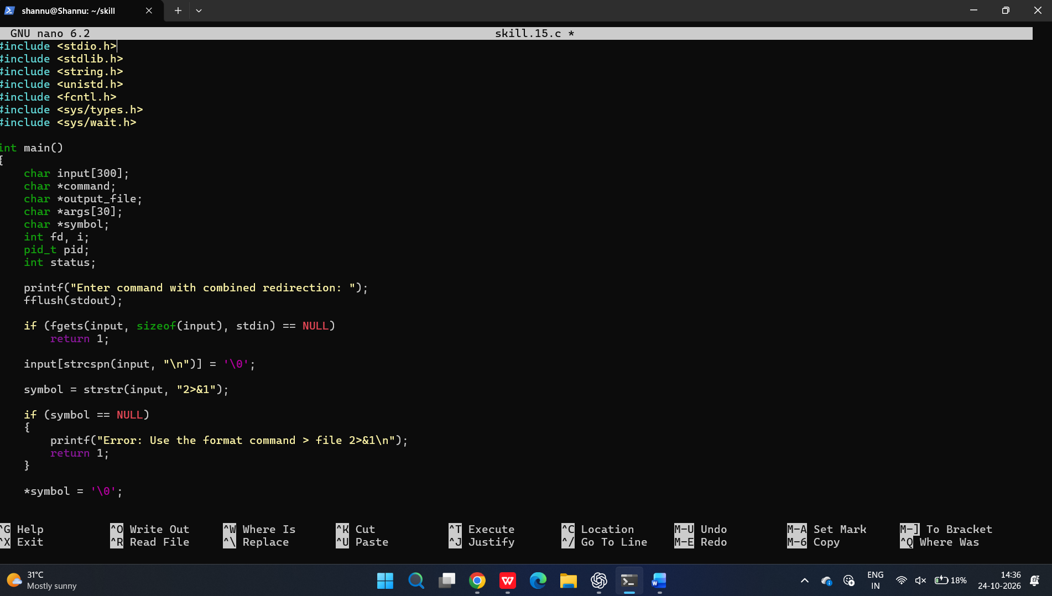
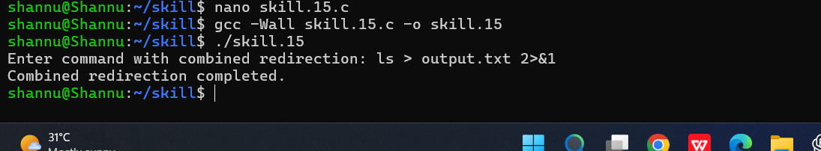

To Parse Complex Commands, Combine Pipes and Redirections, Resolve Execution Order, Validate Syntax, Generate Execution Plans, Test Scenarios.
